Brazilian E-Commerce Dive Deep using SQL & Power BI
1. Business Problem
Olist, a large Brazilian e-commerce platform, connects customers, sellers, and products across Brazil. The company collects data about customers, orders, payments, reviews, products, and delivery locations.
Currently, the company faces challenges in:
- Understanding customer purchasing behavior.
- Analyzing seller performance and product demand.
- Identifying delivery and logistics efficiency.
- Building data-driven dashboards to track KPIs for business decisions.

2. Dataset Overview
You are provided with the Brazilian E-Commerce Public Dataset.
Key tables:
- olist_orders_dataset → Orders information.
- olist_order_items_dataset → Items per order.
- olist_products_dataset → Product details.
- olist_order_payments_dataset → Payments.
- olist_order_reviews_dataset → Reviews & ratings.
- olist_order_customer_dataset → Customer details.
- olist_sellers_dataset → Seller details.
- olist_geolocation_dataset → Location (zip codes).

Please refer to the data schema:
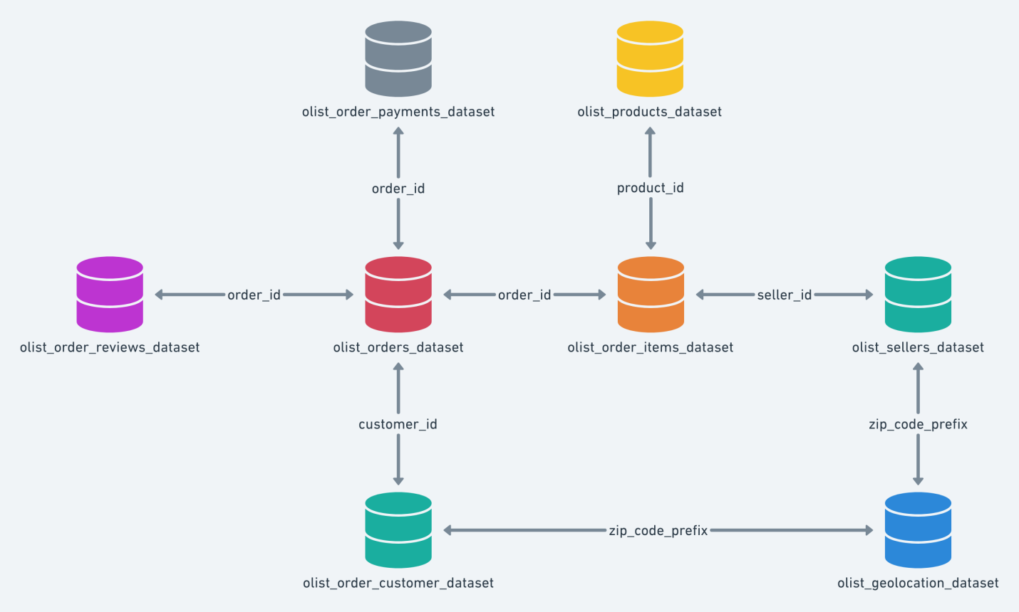

3. Tasks
Part A – SQL
- Create Database & Schema for the dataset.
Part B – Business Questions (Answer via SQL)
- Queries:
  - How many unique customers placed orders?
  - Which are the top 10 most sold product categories?
  - Which sellers generated the highest revenue?
  - What is the average delivery delay (actual vs estimated)?
  - Which payment methods are most common?
  - What is the monthly trend of orders and revenue?
  - What is the average review score by product category?
  - Who are the top customers by spending?
  - Which states have the highest number of orders?
  - Use window functions to rank sellers by revenue within each state.
  - In year 2018, flag each seller as (below target – within target – above target) based on no of sold items and revenue.
- Views:
  - Customer Order Summary View.
  - Seller Performance View.
  - Product Category Sales View.
- Stored Procedures:
  - Get top 10 customers by total spend.
  - Get top 5 sellers by revenue in a given time period.

Part C – Power BI Dashboard
Create an interactive dashboard with the following components:
- Sales Overview → Total orders, revenue, avg. order value.
- Customer Insights → Orders by state, top customers, repeat vs new customers.
- Seller Performance → Top sellers, seller revenue trends, state-based performance.
- Product Analysis → Category-level sales, best & worst performing products.
- Logistics → Avg. delivery days, on-time vs late deliveries.

4. Evaluation Criteria
- SQL Development: 30%
- Business Insights: 40%
- Power BI Dashboard: 30%

